Teamwork & Communication
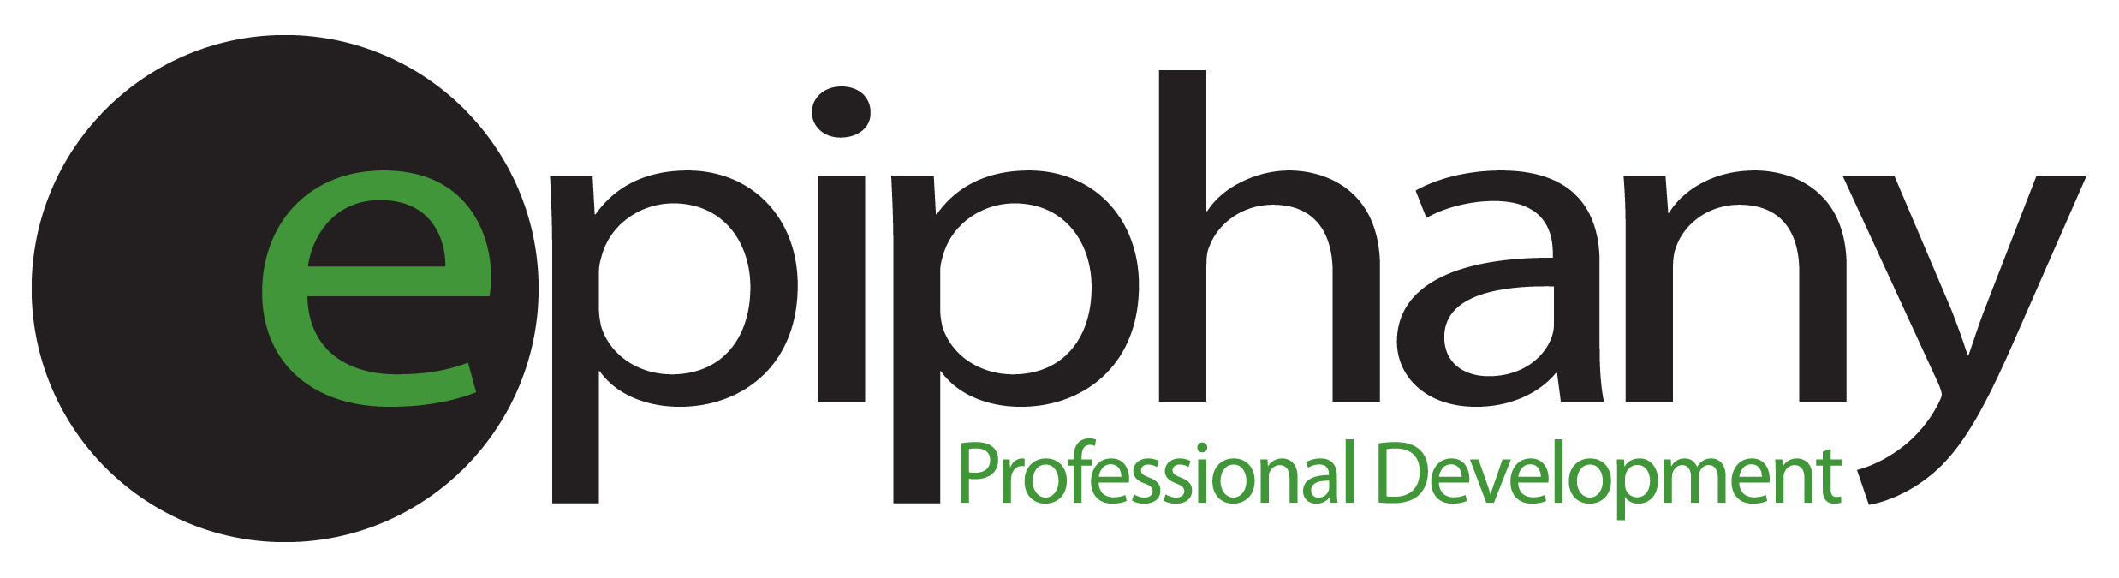
Effective communication is at the foundation or our ability to develop relationships, create understanding and achieve our personal and professional objectives. We all understand the importance of communication, yet misunderstandings, lost productivity, etc due to ineffective communication remains as one of the greatest challenges facing organizations and teams today.
This course will provide insight and direction around communication to enhance its efficacy for teams and individuals.
This session will cover the following topics:
- A review of the team values & goals
- Review or set ground rules for the team.
- Understanding communication styles
- Effectively adjusting & engaging other members of the team
- Active Listening & collaboration
- *The marsh mellow exercise for team building & communication
The workshop is run as a half-day session and participants will have the opportunity to evaluate their communication style through the use of an online Extended DISC assessment. *The final exercise is optional to utilize some of the skills learned throughout the workshop in a fun yet competitive environment.

